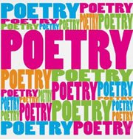

**ENiGMA/ESTABLISHMENT AGREEMENT**

For participation in the ENiGMA Positive Poetry competition

**ENIGMA NATIONAL POETRY WEEK- 21st – 25th May, 2018**

I agree to promote and encourage the participation of the establishment to join in **NATIONAL POETRY WEEK**.

I agree to:

|  |
| --- |
| * Display any information and posters advertising **ENiGMA National Poetry Week** and keep colleagues informed and up-dated. |
| * Encourage colleagues to become involved and engaged in the **ENiGMA National Poetry Week** and promote this in colleague meetings, bulletins, etc. |
| * Encourage learners to become involved and engaged in the **ENiGMA National Poetry Week.** Advertise and circulate a brief (to be provided for all participating), for a National Poetry competition |
| Signed (OLASS Manager) |
| Preferred e-mail contact: |
| Signed (ENiGMA Rep) |
| Preferred e-mail contact: |
| Date: |
| Name of Establishment: |

